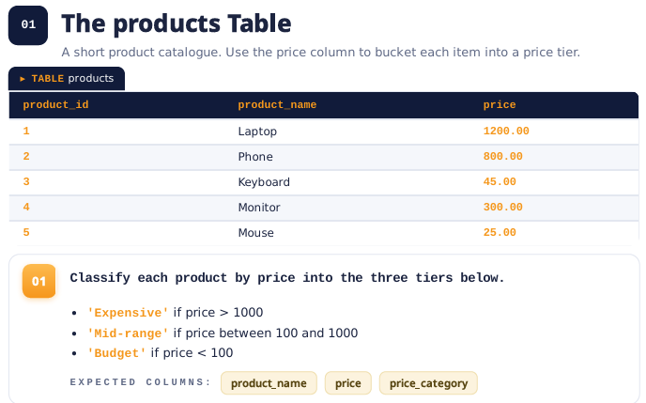

--Step 1: Create a Database/Catalog
CREATE CATALOG IF NOT EXISTS bright;

--Step 2: Creat a Schema
CREATE SCHEMA IF NOT EXISTS bright.product;

--Step 3: Remove the old table (if it exists)
DROP TABLE IF EXISTS bright.product.table;

--Step 4: Create a Table
CREATE TABLE IF NOT EXISTS bright.product.table (
product_ID INT,
product_name STRING,
price INT
);

--Step 5: Insert the information into the table
INSERT INTO bright.product.table VALUES
(1, 'Laptop',1200),
(2, 'Phone', 800),
(3, 'Keyboard', 45),
(4, 'Monitor', 300),
(5, 'Mouse', 25);

--Step 6: Check if the table is created correctly
SELECT*
FROM bright.product.table;
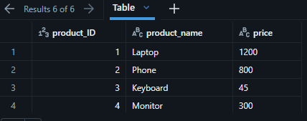
Activity Databricks - Syntax:
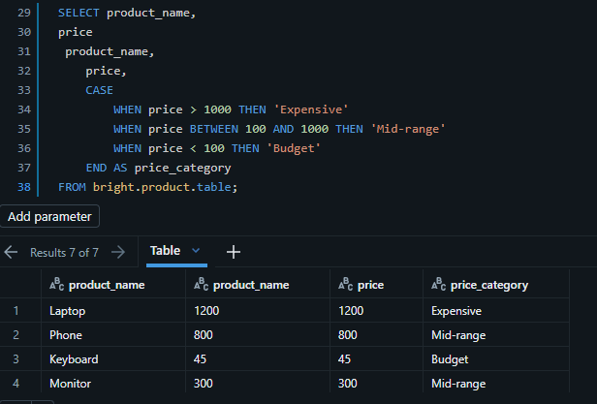

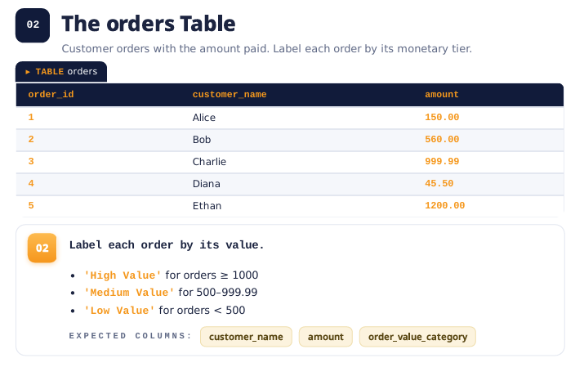

--Step 1: Create a Database/Catalog
CREATE CATALOG IF NOT EXISTS bright;

--Step 2: Creat a Schema
CREATE SCHEMA IF NOT EXISTS bright.order;

--Step 3: Remove the old table (if it exists)
DROP TABLE IF EXISTS bright.order.table;

--Step 4: Create a Table
CREATE TABLE IF NOT EXISTS bright.order.table (
order_ID INT,
customer_name STRING,
amount INT
);

--Step 5: Insert the information into the table
INSERT INTO bright.order.table VALUES
(1, 'Alice',150),
(2, 'Bob', 550),
(3, 'Charlie', 999.99),
(4, 'Diana', 450.50),
(5, 'Ethan', 12000);

--Step 6: Check if the table is created correctly
SELECT*
FROM bright.order.table;
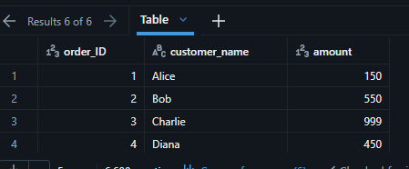
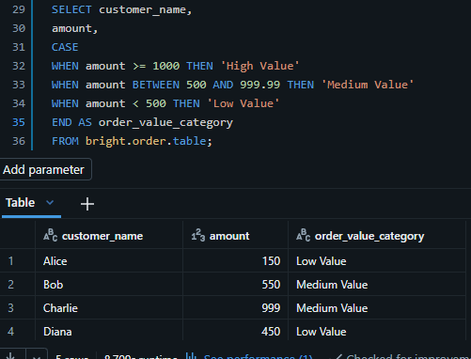
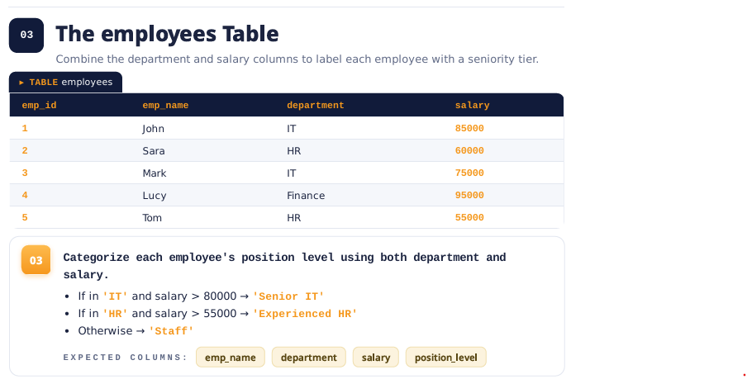
--Step 1: Create a Database/Catalog
CREATE CATALOG IF NOT EXISTS bright;

--Step 2: Creat a Schema
CREATE SCHEMA IF NOT EXISTS bright.employees;

--Step 3: Remove the old table (if it exists)
DROP TABLE IF EXISTS bright.employees.table;

--Step 4: Create a Table
CREATE TABLE IF NOT EXISTS bright.employees.table (
emp_ID INT,
emp_name STRING,
department STRING,
salary INT
);

--Step 5: Insert the information into the table
INSERT INTO bright.employees.table VALUES
(1, 'John', 'IT', 85000),
(2, 'Sara', 'HR', 60000),
(3, 'Mark', 'IT', 75000),
(4, 'Lucy', 'Finance', 95000),
(5, 'Tom', 'IT', 55000);

--Step 6: Check if the table is created correctly
SELECT*
FROM bright.employees.table;
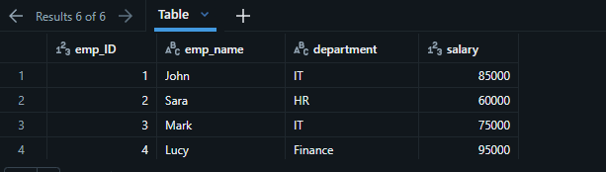

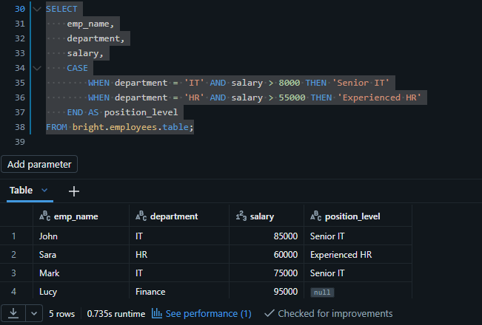

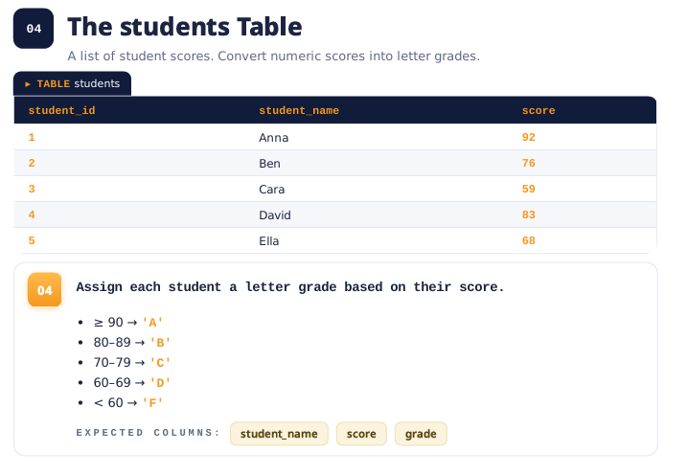
--Step 1: Create a Database/Catalog
CREATE CATALOG IF NOT EXISTS bright;

--Step 2: Creat a Schema
CREATE SCHEMA IF NOT EXISTS bright.student;

--Step 3: Remove the old table (if it exists)
DROP TABLE IF EXISTS bright.student.table;

--Step 4: Create a Table
CREATE TABLE IF NOT EXISTS bright.student.table (
student_ID INT,
studentt_name STRING,
suject_name STRING,
score INT
);

--Step 5: Insert the information into the table
INSERT INTO bright.student.table VALUES
(1, 'Anna', 'IT', 92),
(2, 'Sara', 'HR', 76),
(3, 'Mark', 'IT', 59),
(4, 'Lucy', 'Finance', 83),
(5, 'Tom', 'IT', 68);

--Step 6: Check if the table is created correctly
SELECT*
FROM bright.student.table;
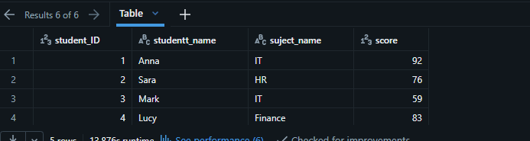
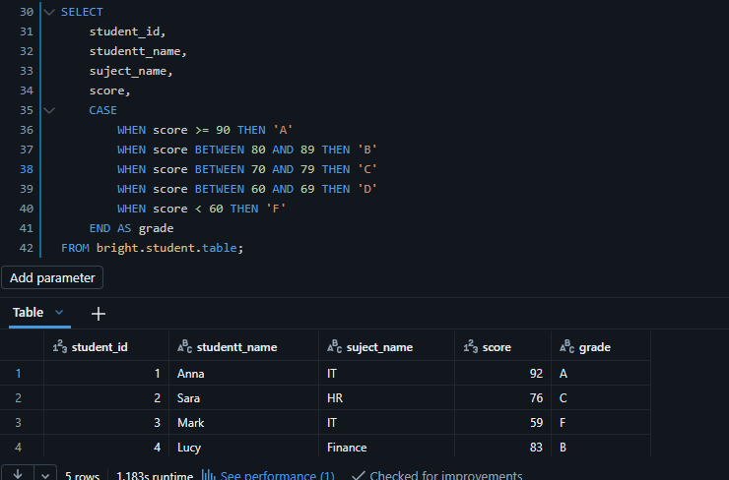
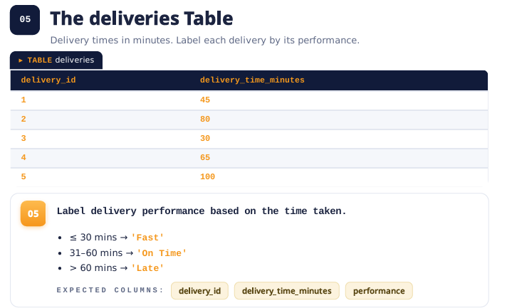
-- Step 1: Create a Database/Catalog
CREATE CATALOG IF NOT EXISTS bright;

-- Step 2: Create a Schema
CREATE SCHEMA IF NOT EXISTS bright.deliveries;

-- Step 3: Remove the old table (if it exists)
DROP TABLE IF EXISTS bright.deliveries.table;

-- Step 4: Create a Table
CREATE TABLE IF NOT EXISTS bright.deliveries.table (
delivery_ID INT,
delivery_time_minutes INT
);

-- Step 5: Insert the information into the table
INSERT INTO bright.deliveries.table VALUES
(1, 45),
(2, 80),
(3, 30),
(4, 65),
(5, 100);

-- Step 6: Check if the table was created correctly
SELECT *
FROM bright.deliveries.table;
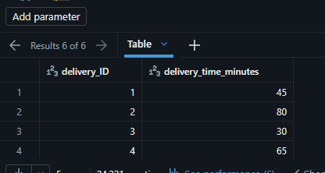

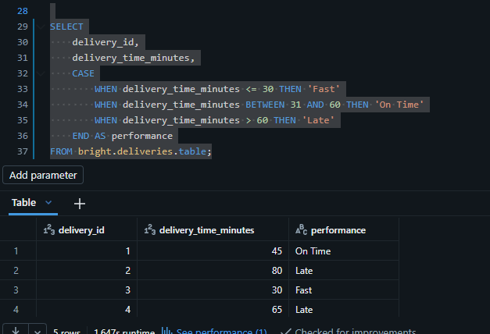
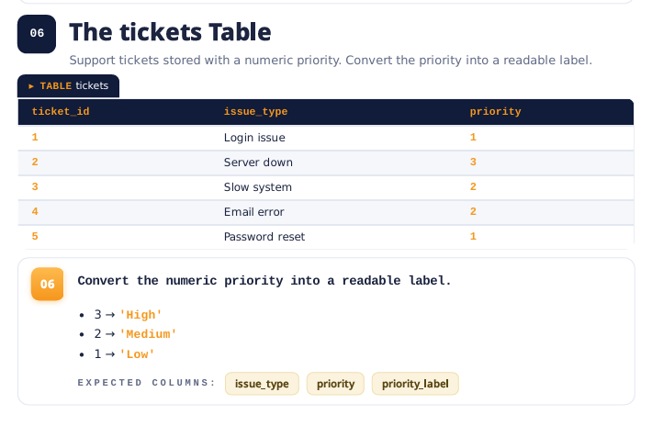
-- Step 1: Create a Database/Catalog
CREATE CATALOG IF NOT EXISTS bright;

-- Step 2: Create a Schema
CREATE SCHEMA IF NOT EXISTS bright.tickets;

-- Step 3: Remove the old table (if it exists)
DROP TABLE IF EXISTS bright.tickets.table;

-- Step 4: Create a Table
CREATE TABLE IF NOT EXISTS bright.tickets.table (
ticket_ID INT,
issus_type STRING,
prioritY INT
);

-- Step 5: Insert the information into the table
INSERT INTO bright.tickets.table VALUES
(1, 'Login issue', 1),
(2, 'Server down', 3),
(3, 'Slow system', 2),
(4, 'Email error', 2),
(5, 'Password reset', 1);

-- Step 6: Check if the table was created correctly
SELECT *
FROM bright.deliveries.table;
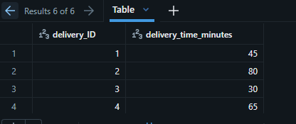
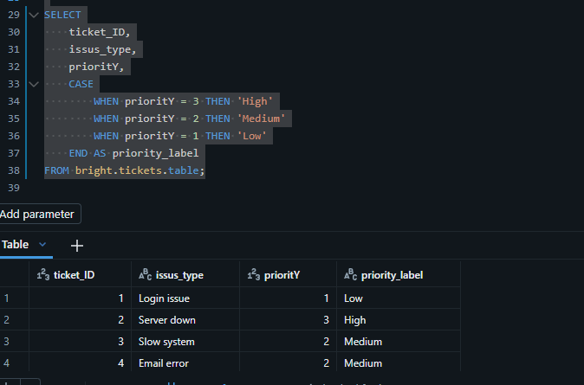
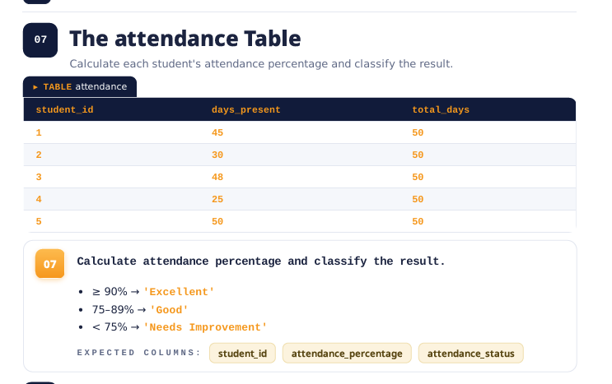
-- Step 1: Create a Database/Catalog
CREATE CATALOG IF NOT EXISTS bright;

-- Step 2: Create a Schema
CREATE SCHEMA IF NOT EXISTS bright.attendance;

-- Step 3: Remove the old table (if it exists)
DROP TABLE IF EXISTS bright.attendance.table;

-- Step 4: Create a Table
CREATE TABLE IF NOT EXISTS bright.attendance.table (
student_ID INT,
day_present INT,
total_days INT
);

-- Step 5: Insert the information into the table
INSERT INTO bright.attendance.table VALUES
(1, 45, 50),
(2, 30, 50),
(3, 48, 50),
(4, 25, 50),
(5, 50, 50);

-- Step 6: Check if the table was created correctly
SELECT *
FROM bright.attendance.table;
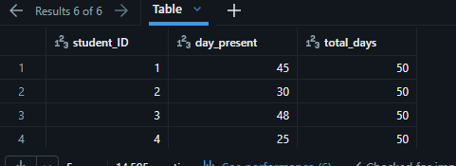
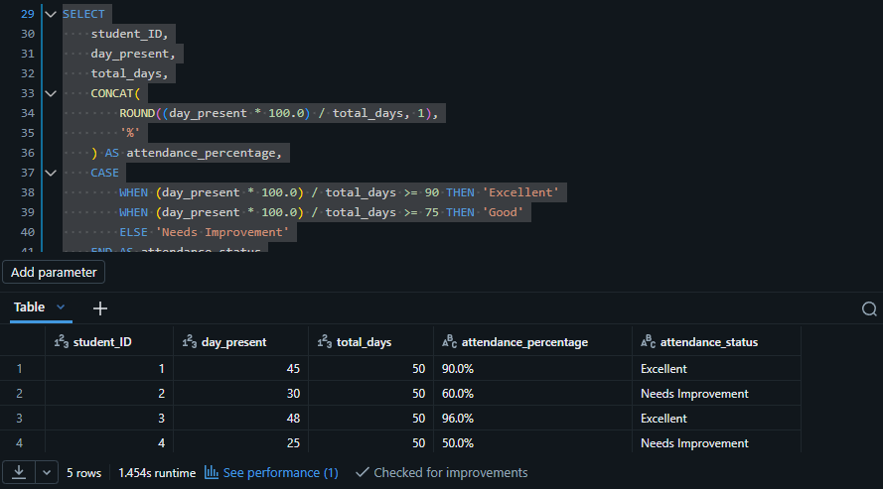
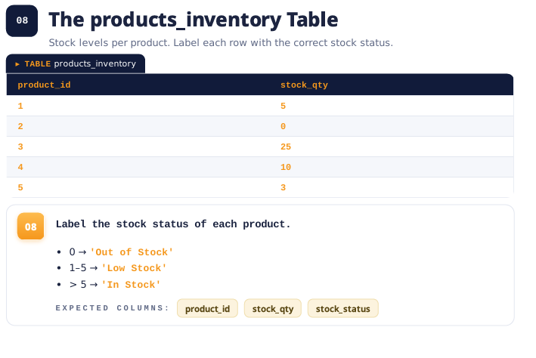
-- Step 1: Create a Database/Catalog
CREATE CATALOG IF NOT EXISTS bright;

-- Step 2: Create a Schema
CREATE SCHEMA IF NOT EXISTS bright.product_inventory;

-- Step 3: Remove the old table (if it exists)
DROP TABLE IF EXISTS bright.product_inventory.table;

-- Step 4: Create a Table
CREATE TABLE IF NOT EXISTS bright.product_inventory.table (
product_ID INT,
stock_qty INT

);

-- Step 5: Insert the information into the table
INSERT INTO bright.product_inventory.table VALUES
(1, 5),
(2, 8),
(3, 25),
(4, 10),
(5, 3);

-- Step 6: Check if the table was created correctly
SELECT *
FROM bright.product_inventory.table;
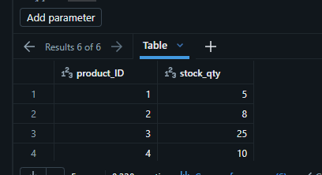
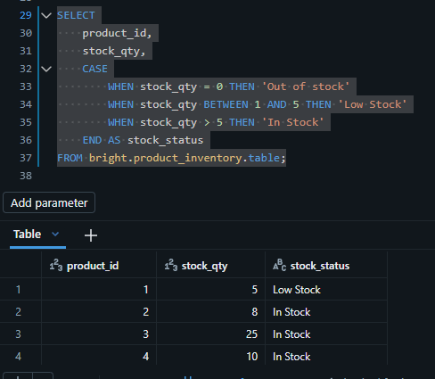

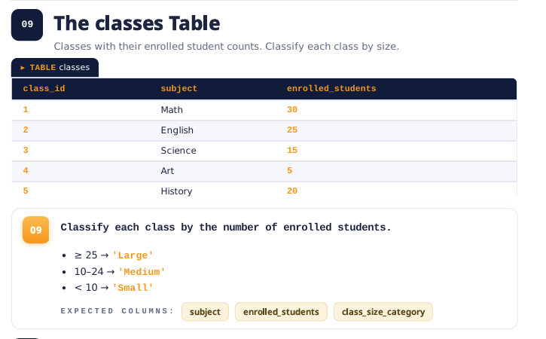
-- Step 1: Create a Database/Catalog
CREATE CATALOG IF NOT EXISTS bright;

-- Step 2: Create a Schema
CREATE SCHEMA IF NOT EXISTS bright.class;

-- Step 3: Remove the old table (if it exists)
DROP TABLE IF EXISTS bright.class.table;

-- Step 4: Create a Table
CREATE TABLE IF NOT EXISTS bright.class.table (
class_ID INT,
subject STRING,
enrolled_students INT

);

-- Step 5: Insert the information into the table
INSERT INTO bright.class.table VALUES
(1, 'Math', 30),
(2, 'English', 25),
(3, 'Science', 15),
(4, 'Art', 5),
(5, 'History', 20);

-- Step 6: Check if the table was created correctly
SELECT *
FROM bright.class.table;
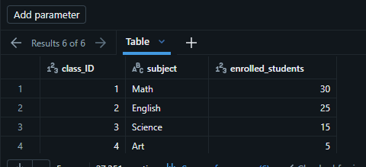
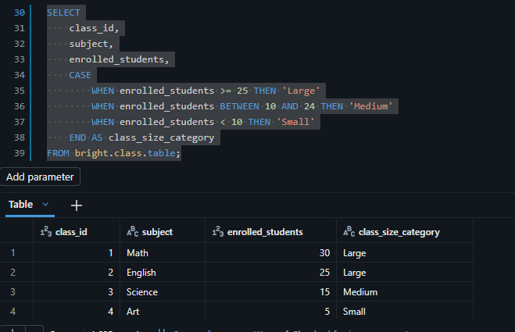
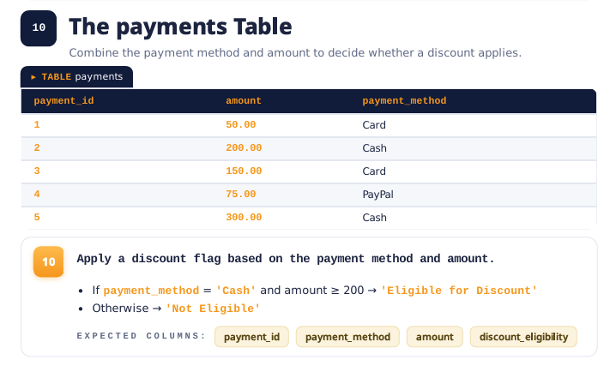
-- Step 1: Create a Database/Catalog
CREATE CATALOG IF NOT EXISTS bright;

-- Step 2: Create a Schema
CREATE SCHEMA IF NOT EXISTS bright.payments;

-- Step 3: Remove the old table (if it exists)
DROP TABLE IF EXISTS bright.payments.table;

-- Step 4: Create a Table
CREATE TABLE IF NOT EXISTS bright.payments.table (
class_ID INT,
amount INT,
payment_method STRING

);

-- Step 5: Insert the information into the table
INSERT INTO bright.payments.table VALUES
(1, 50.00, 'Card'),
(2, 200.00, 'Cash'),
(3, 150.00, 'Card'),
(4, 75.00, 'PayPal'),
(5, 300.00, 'Cash');

-- Step 6: Check if the table was created correctly
SELECT *
FROM bright.payments.table;
